Summary of Changes

- DOLWIN-1044: Update the QUEST E-Contact load to notify users if an admin record was created with the load. Currently if there is no admin record for the UI/RUN being loaded, the load will create an empty admin and quarterly record for the account on the load file. The only data updated will be the email and/or web URL provided on the load file. All other admin information will be empty. The quarterly record will be created for the current yr/qtr.

With this update, the records will still be created, but there will be a notification in the summary file indicating that a new record was created so the user can act accordingly:
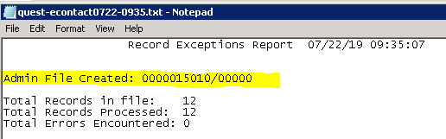

- DOLWIN-1131: Update the WIN202 Quarterly load program to not load the county, town and/or NAICS codes if the account is on the current ARS and the codes have valid values. There was a bug with the WIN quarterly load that was causing all records in the file to have the codes bypassed after the first account on the ARS was identified. The fix is to look at each account individually and assess whether that account is on the current ARS. If it is, bypass the loading of the codes. If it is not, load the codes.

- DOLWIN-1183: Special procedure to update the BLS suggested values for various Edit Parameters
The “BLS” (default) edit parameters found in the screen below have been updated per BLS request to match those used in BLS processing. Statesxx can update their parameters to these values to help reduce their workload: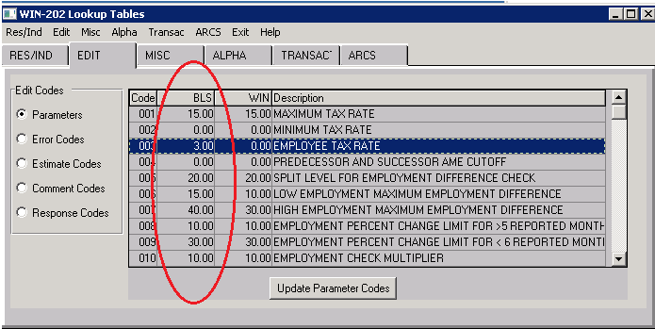

Also, the above screen has been modified to now show both the state value and the “BLS” default values.
The list of edits associated with each parameter has been moved to the pop up window if you double click
on a parameter:
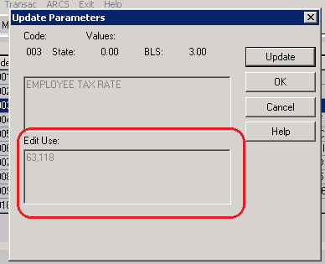

Please see the special procedure details in the Installation document included with this release. Once run,there will be a file (Edit-Parameter-Changes.txt) in your reports folder with the details (see below) and a note if your current value is different from the new suggested BLS value:
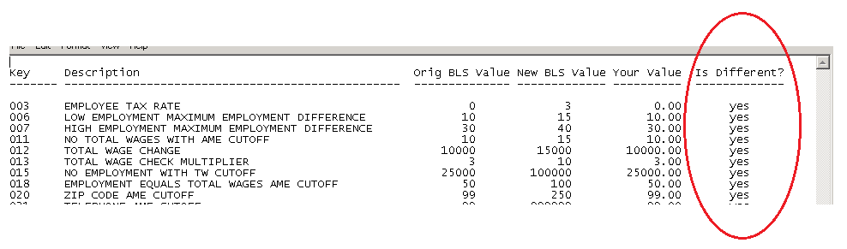

Included with this release is a document (WIN Default Edit Parameter Changes.docx) with the details of the parameters for which the default value has been modified.

- DOLWIN-1184: Increase the size of the fields on the batch manager popup details box
The pop-up box that displays when pressing F2 on a Batch Manager job has been enhanced to allow all parameters to be seen instead of scrolling off the screen.

The popup on the left is the new look, with bigger areas for the title and the parameters. The popup on the right is the old/current look (before this update is applied):
